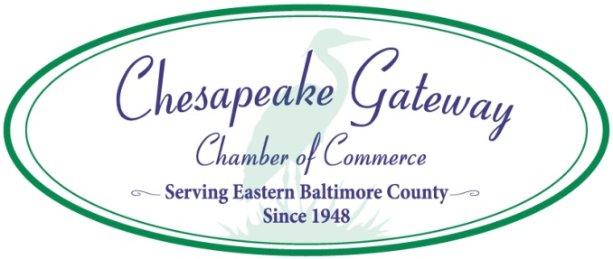
Eastern Baltimore County Task Force – Focused on Essex
Even before the Task Force was formed, the co-chairs of this group began grassroots efforts to clean up eastern Baltimore County and its waterways. Through their efforts and those of the Task Force, much has been accomplished with significant help from Baltimore County government and the State of Maryland. Here is a list of improvements which were made possible through this team effort:
Phase 1 – Eliminating Blight (will continue well into the future)
- Replaced damaged or missing metal trash cans that go in the green liners along Eastern Blvd.
- Encouraged businesses to improve their dumpster habits and clean up trash near their businesses; citations issued when they did not comply
- Cut down trees along the Blvd. (largely dead trees and ones which had outgrown the area where they were planted, as the roots were causing damage to the sidewalks, creating hazards) and cut back trees, shrubs and overgrowth, especially in the alleys, so emergency vehicles can pass through
- Cleaned up vacant properties
- Encouraged business and homeowners to paint over or clean off graffiti
- After a “sweep” from Baltimore County, abandoned vehicles, unsafe structures and other large debris from behind businesses and homes were removed
- Successfully fought to have Baltimore County initiate a rat attack pilot program, including public education, code enforcement, extermination and an extra trash pick-up. This program is now being utilized in other parts of Baltimore County as well.
- Convinced Baltimore County to repave an alley with that had horrible potholes and broken concrete
- Persuaded the owner of the building housing Social Services to clean the black mold off of the building and sidewalk
Phase 2 – Beautification (in conjunction with Phase 1; accomplished largely through grants from Baltimore County and the State of Maryland)
- Obtained a Sustainable Community designation for Essex, which provides access to a comprehensive package of financial and other resources that support strategies for community development, revitalization and sustainability
- Hired a contractor to fix the brickwork on planters along the Blvd. and at a bus stop
- Installed parking blocks in the parking spaces to protect the planters from future damage
- Replaced rotting wood on 32 benches on all the cement planters in the business district
- Purchased 16 large terra cotta pots and hired a landscaper to fill with flowers, plants and shrubs and maintain them for the last two years (water, fertilizer, mulch, weeding, etc.)
- The landscaper also replaced old soil and planted, fertilized and mulched flowers, grasses and shrubs in 26 the small and large square planters in the downtown Essex area. He also maintains those planters.
- With the assistance of a team of landscape architects and state highway representatives, designed the gateway gardens (near the Essex cube and by Eastern Blvd. and Old Eastern Ave.). The cube garden has been weeded, planted with beautiful plants and flowers, mulched, and fertilized and will be regularly maintained. For the other garden, a volunteer repaired and painted the sign, and planting will be completed in the September/October timeframe.
- Worked with Baltimore County to improve lighting along the Blvd. Baltimore County has inspected all the lamp posts and determined that most of them need to be replaced. These lamp posts, globes and lighting have been ordered, and new ones should be installed by this winter.
- With the State grant money, NDC also hired a designer, who created a logo and banner designs to go on the new lamp posts.
- Identified issues in Cox’s Point Park, many of which now have been addressed by Baltimore County, including replacing/repairing 8 grills, repairing 4 picnic tables and 3 benches, replacing barrier posts along the roadway, patched part of the parking lot, repaired the pier in the back of the park. They also are addressing the issue regarding the gates and posts leading into the park and cutting the grass once a week, weather permitting. Boy Scouts also added fishing line recyclable containers in 4 locations. We are hoping that signage and additional issues will be addressed by Baltimore County Recreation and Parks before year-end.
- Signs reminding people not to litter have been designed and will be placed on all trash cans this fall.
- New signs identifying public parking will be printed and installed in September or October.
- A façade program for businesses will be launched in late 2019, providing businesses with financial support for improving their storefronts.
Grants
- Created a streetscape initiative and obtained a Commercial Revitalization Action Grant from Baltimore County’s Planning Department in 2018 and 2019 ($10,000 each year) to begin to implement the plan
- Obtained $100,000 through a 2019 Community Legacy Grant from the State of Maryland’s Department of Health and Community Development to continue the streetscape initiative
- On behalf of the Task Force, the Neighborhood Design Center (NDC) applied for and received a $20,000 2019 Operational Assistance Grant from DHCD to engage Essex stakeholders in discussions about the Eastern Blvd. main street area and identify and prioritize potential streetscape improvement projects.
- On behalf of Our Lady of Mt. Carmel, applied for and received two 2019 Community Legacy Grants from DHCD, each in the amount of $125,000. One grant has been used to renovate their community center, and the other will be used to design and build a new ball field for the community’s use.
- Obtained a $20,000 Operational Assistance Grant through DHCD to hire a part-time project manager for the Essex Streetscape project.
- Were awarded a $300 Gayle Adams Community Service Grant to plant flowers in the garden with the Essex cube
- Applied for a 2020 Community Legacy Grant through DHCD to continue the Essex streetscape program, including expanding the façade program, maintaining the gardens, flower pots and planters, purchase speed signs for traffic calming, power wash sidewalks, and paint the Back River bridge.
- Applied for a 2020 Community Legacy Grant to obtain additional funds for the ball field at Our Lady of Mt. Carmel.

